Alerts data missing on Alerts page while user select "View All" link from Dashboard System Alert section and page redirected to Alerts page. **Working**

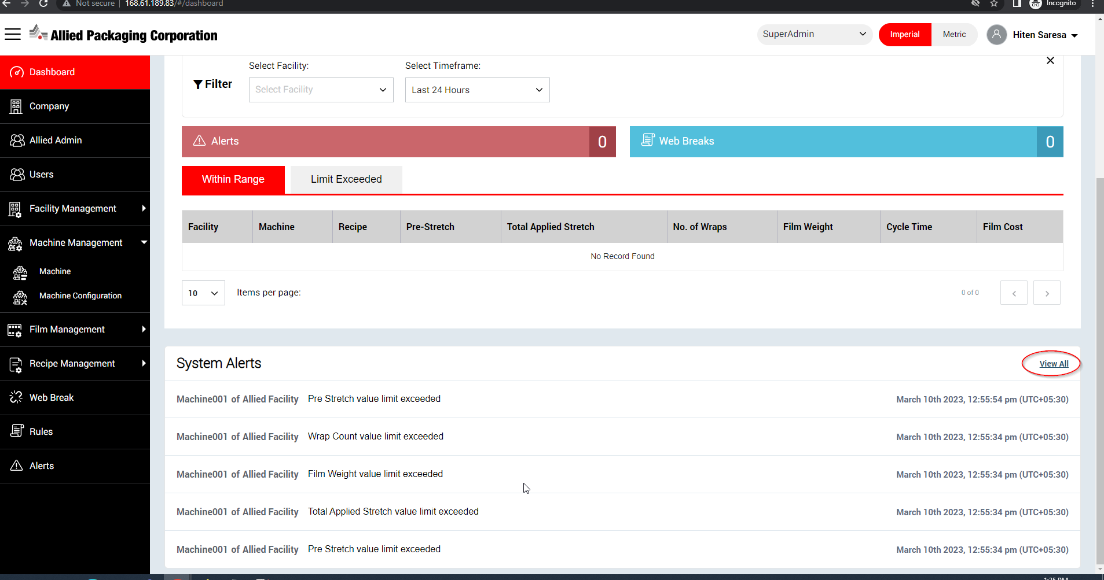

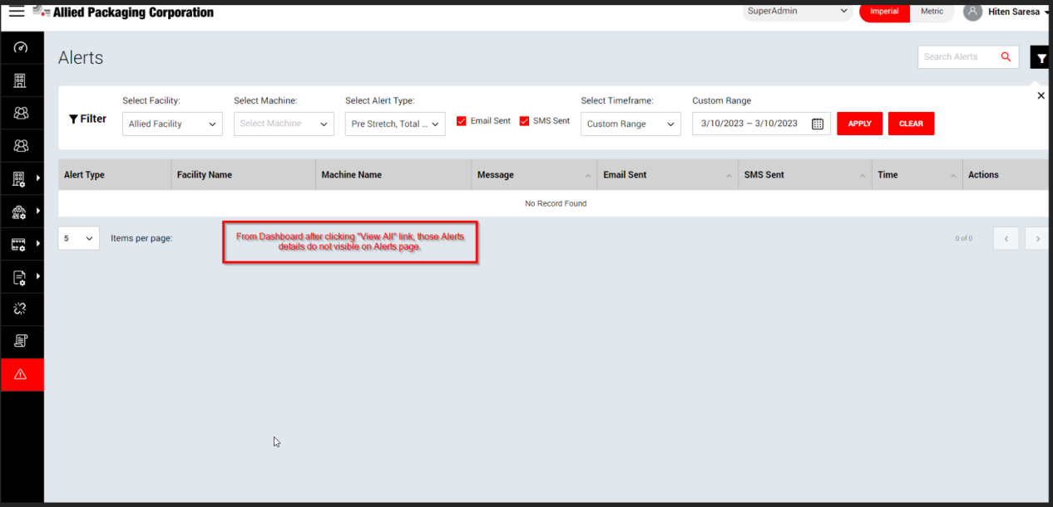

From Add / Update User page, Validation message need to be corrected for Email field - **Working**

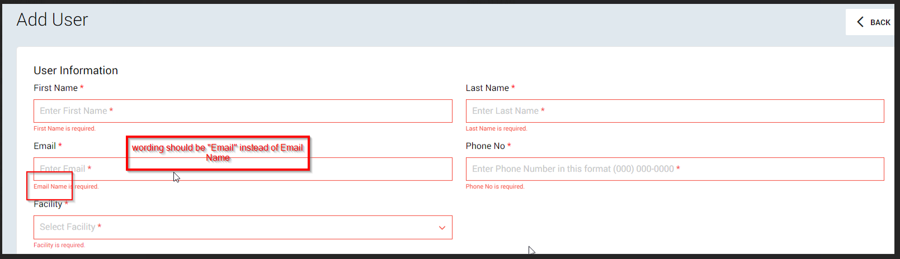

From Add/Update User page, while user entering an existing Email address page showing with loader bar. - **Still throwing error**

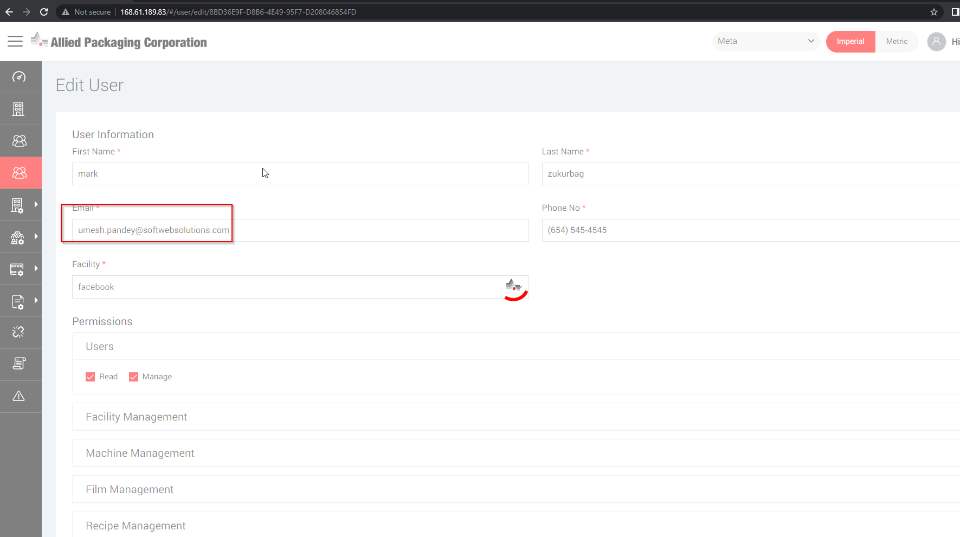

Speedo meter icon missing in PreStretch section on Machine RealTime Data page - **Working**

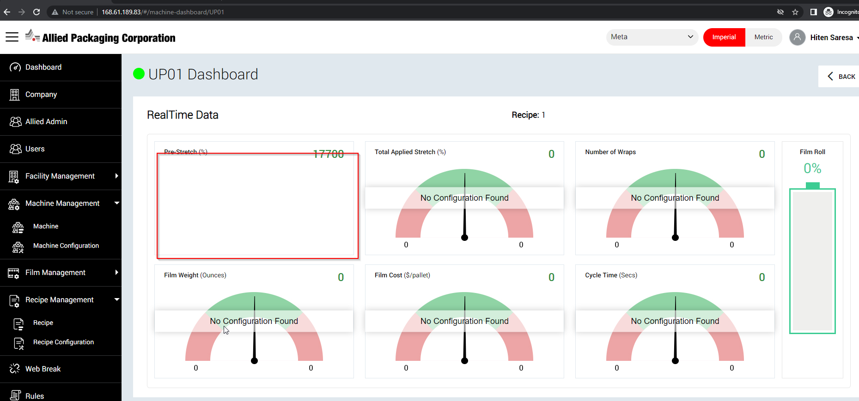

On Dashboard page, Machine count seeing 10 record but when user goto Machine page 6 records are seeing. **Still count mismatched**

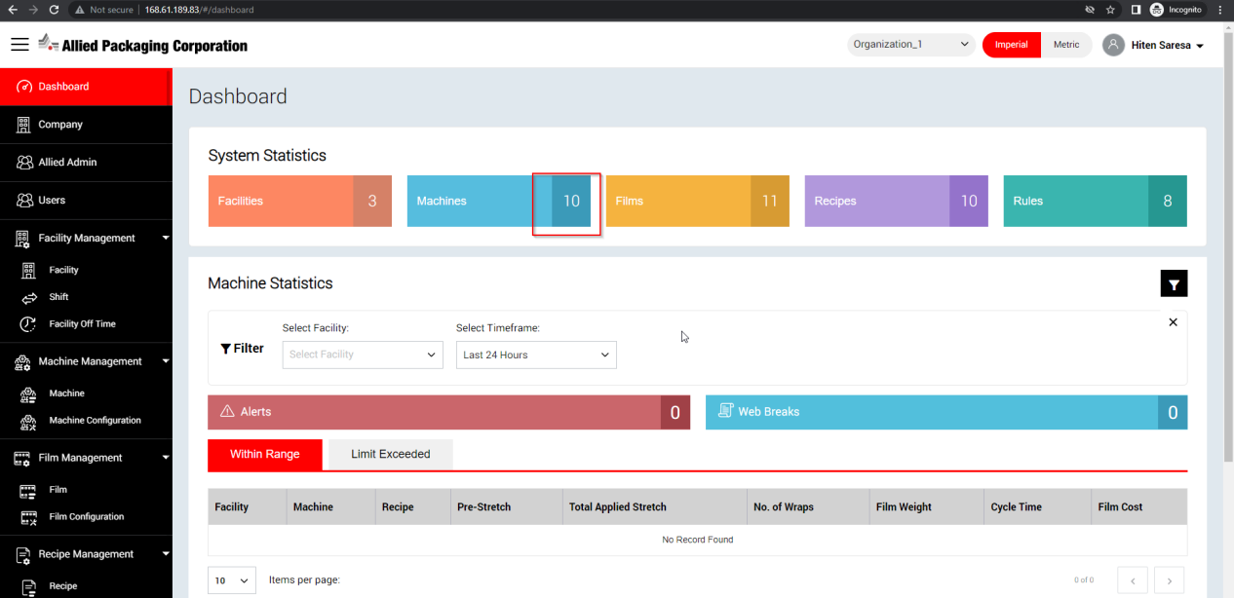

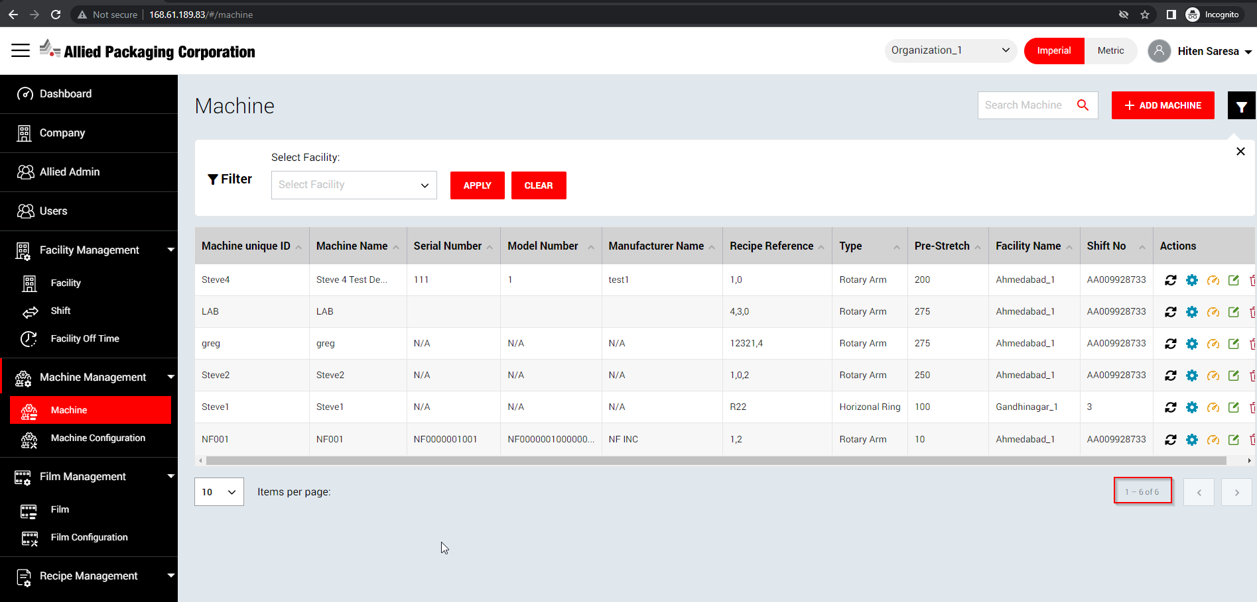

From the Alerts page when filter the Records and records are found , Email sent / SMS Sent column do not shows with right ticket if user receives the Alert via Email and SMS - **Working**

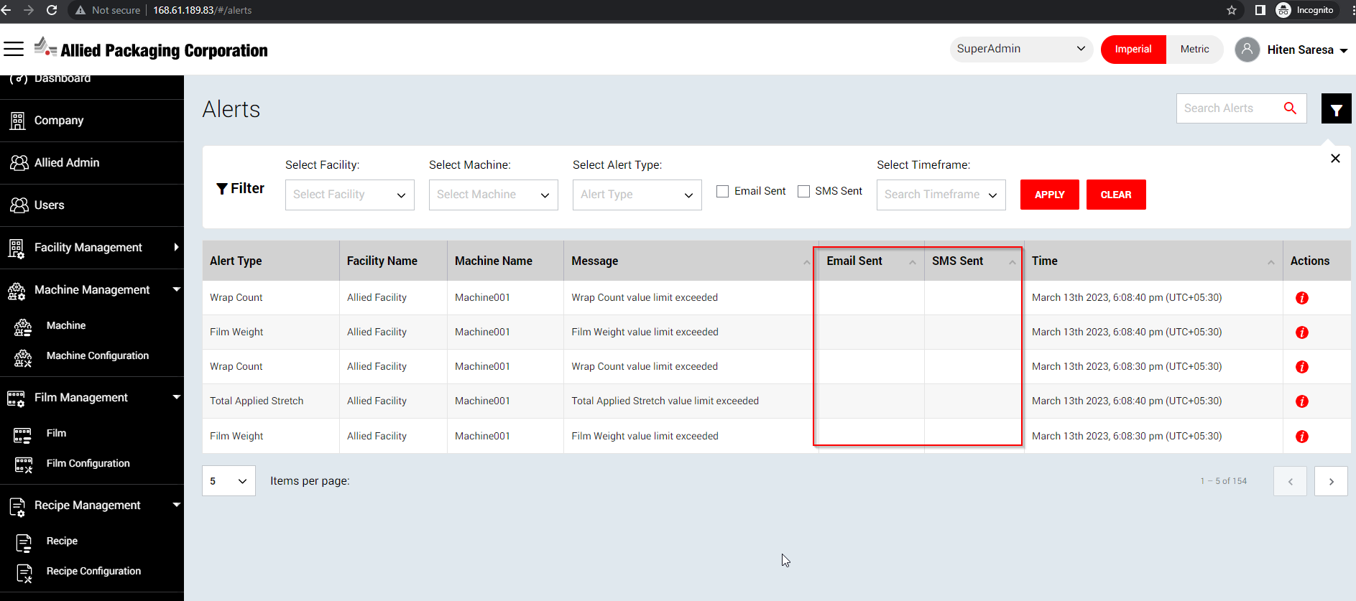

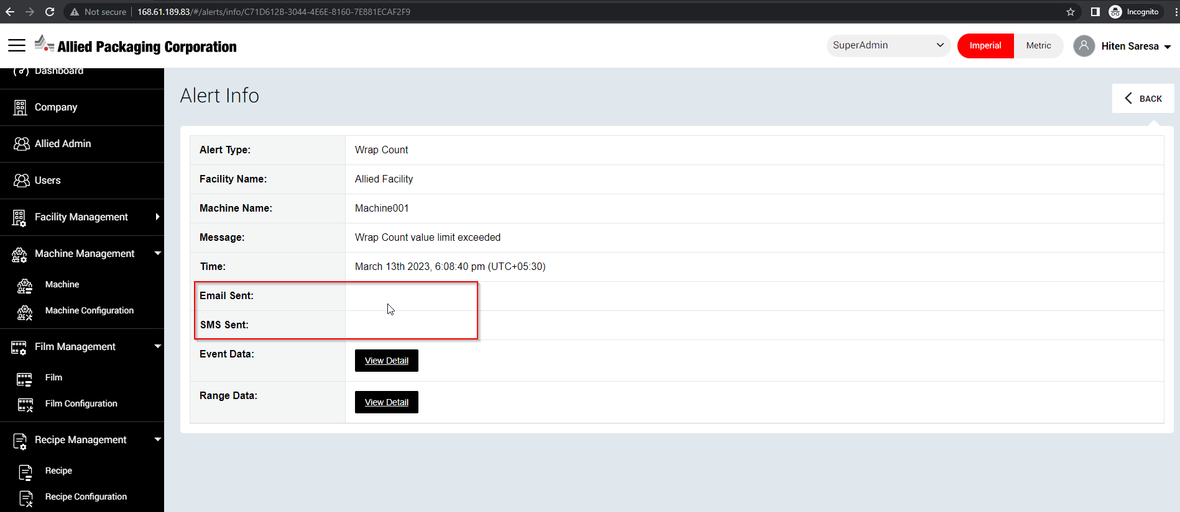

After filtering with below criteria, records do not shows up but pagination are displaying at bottom - **Working**

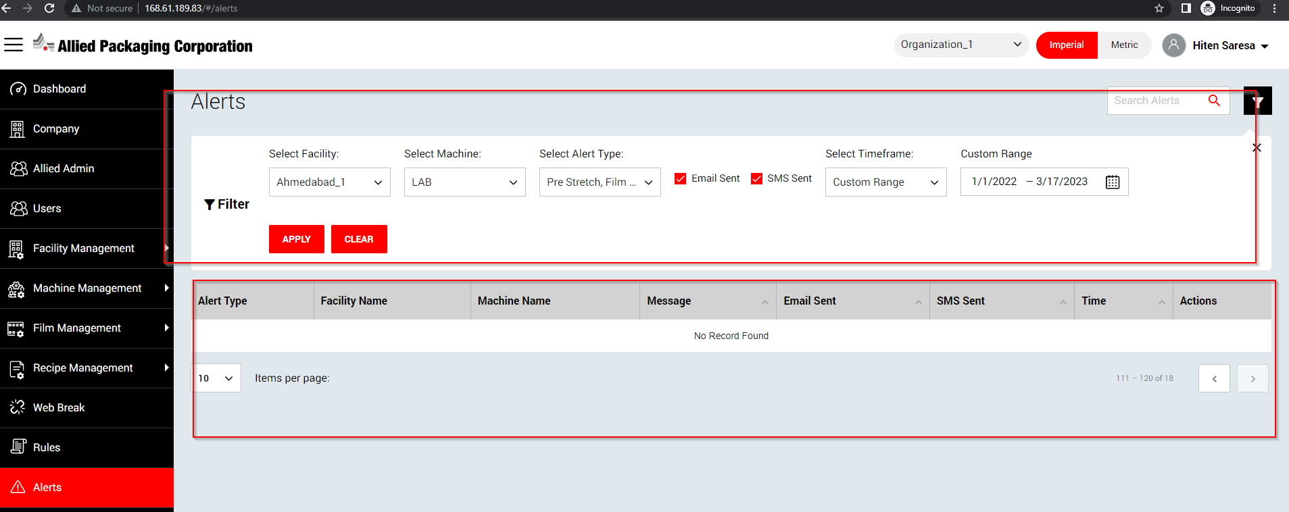

While user sorting with below highlighted columns, error throwing at top right corner afterward all filter criteria and functionality seems stopped. - **Working**

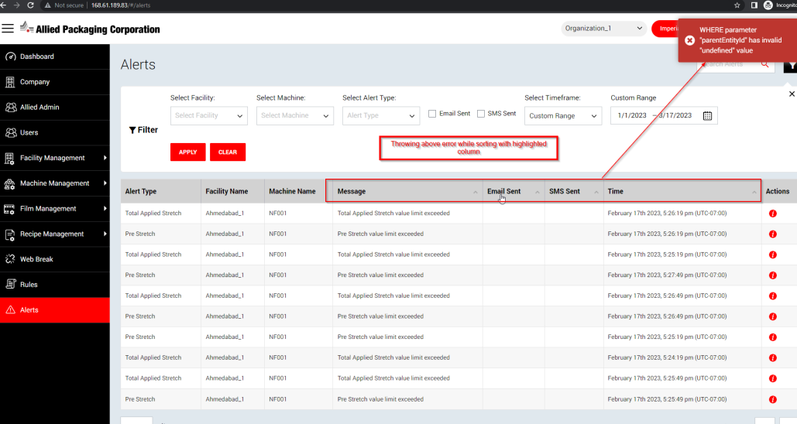

Once user found the Alerts Record and click on “I” icon from grid afterward click “Back” button, top Filter criteria getting reset which should not be happened.

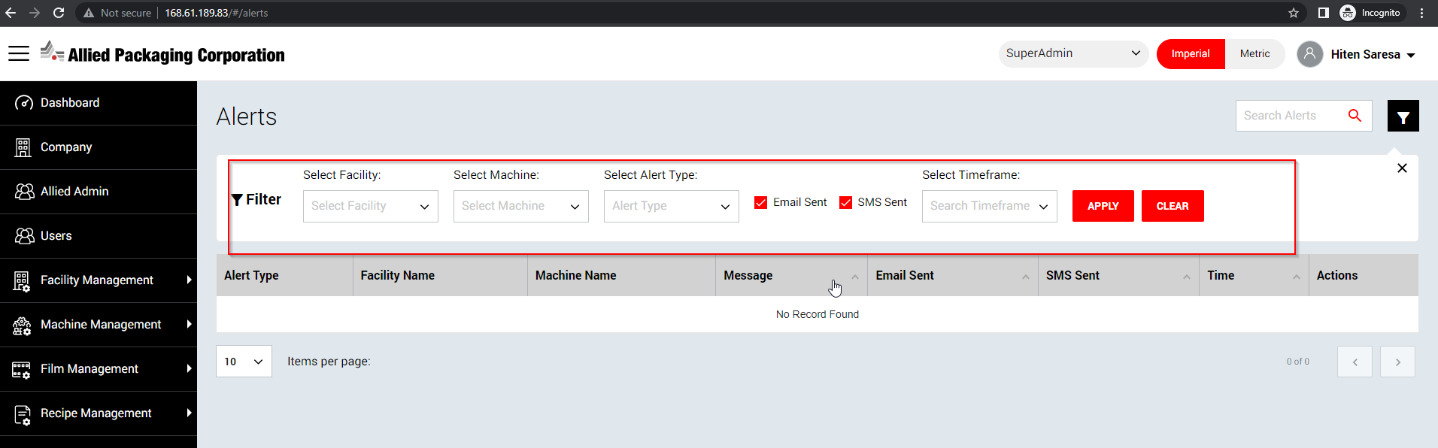

once user logged into application and keep in stand mode till 15-20 mnts and when just reload any page , user logged out with "Unknown" error in all browsers

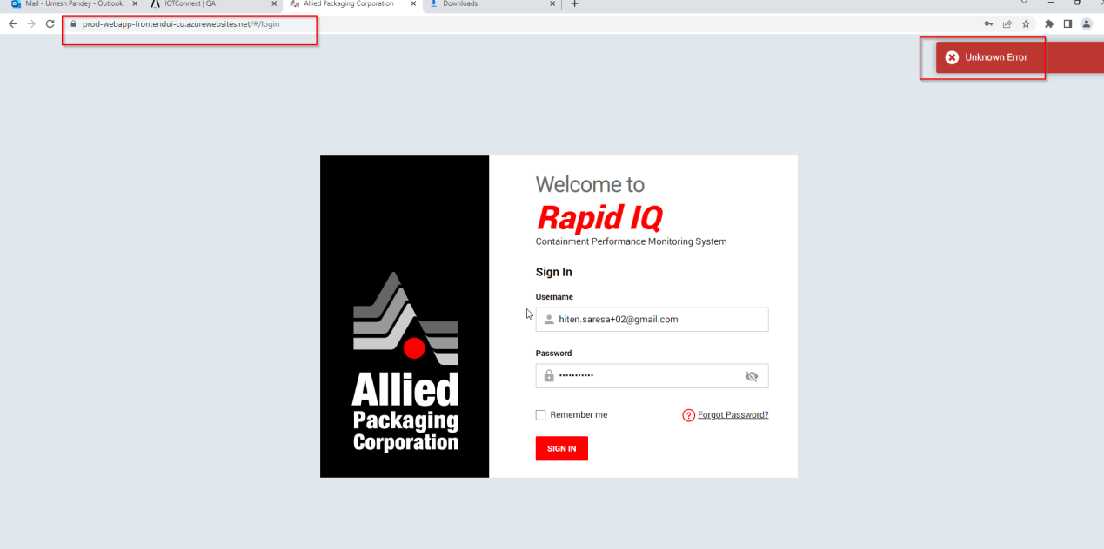

While adding a new user by providing the details , error throwing as shown in screen shot but after refreshing the page, record seems created there.

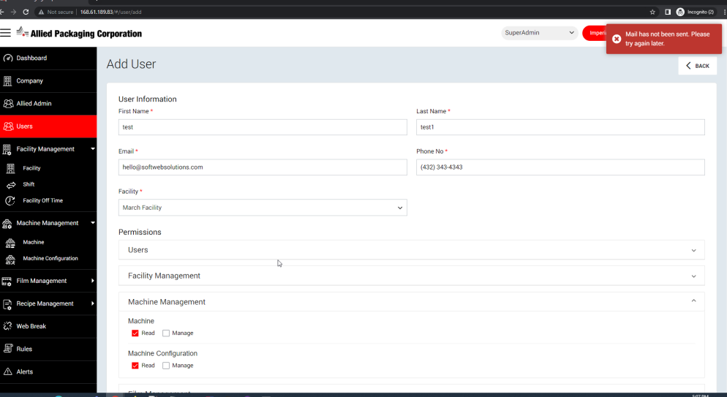

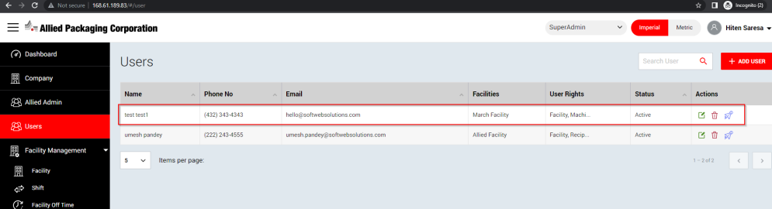

Asterisk (*) sign missing on Wraps field.

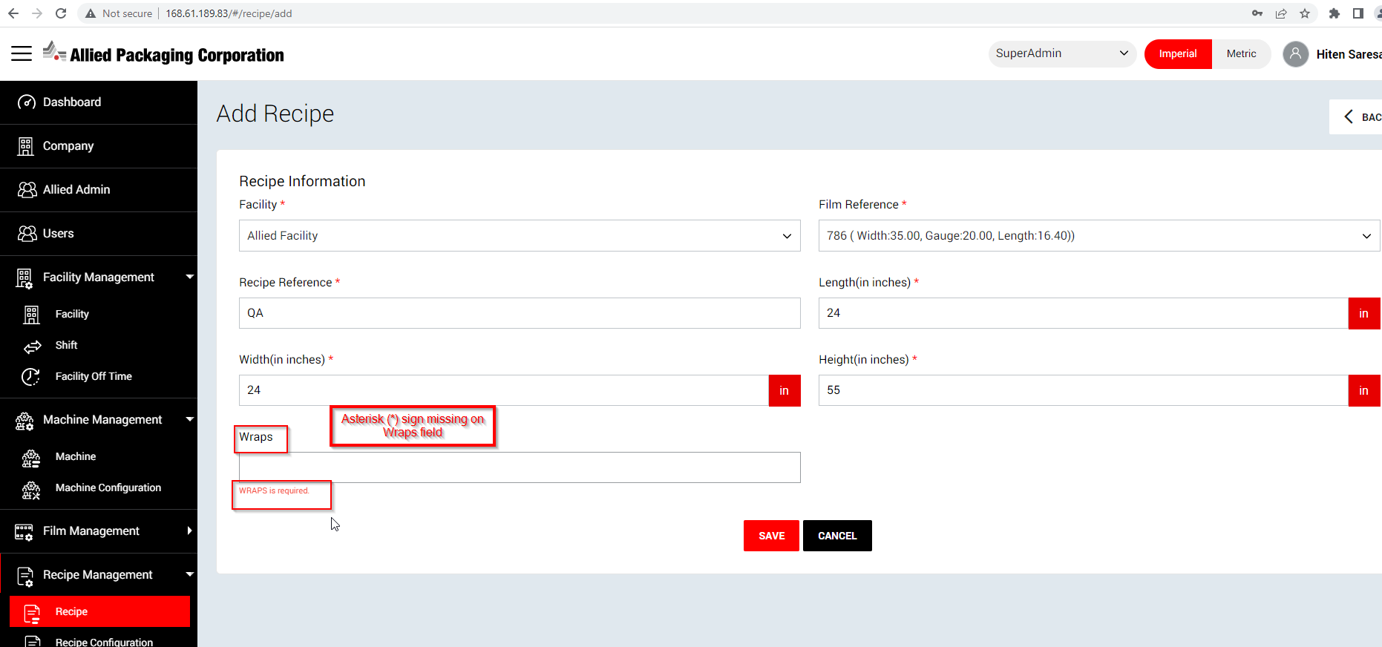

if value comes within range / exceeded then do not shows in Within Range / Exceeded limit tab 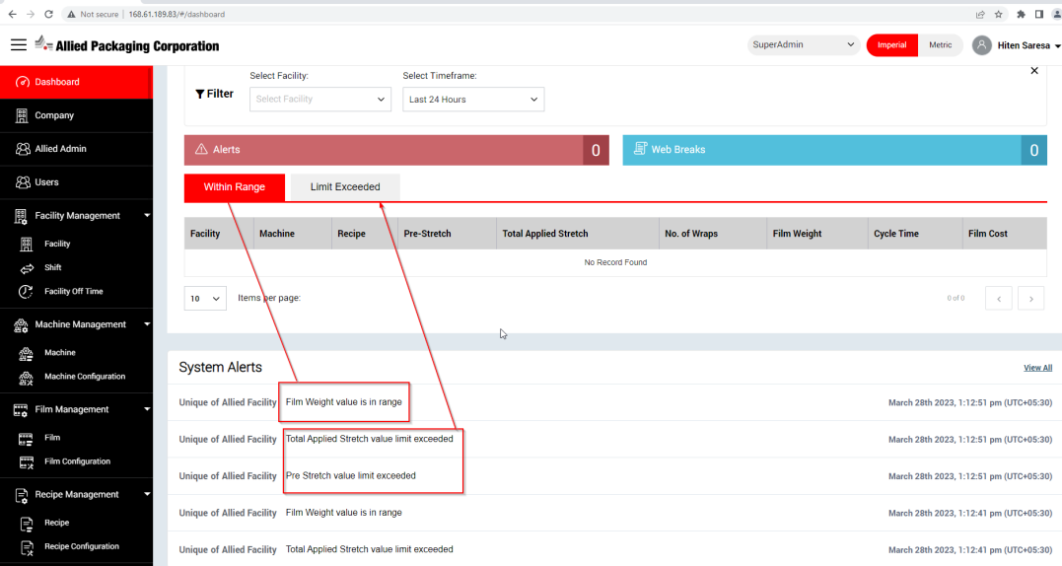

For Alert related, 2 different messages are displaying and that’s why user getting confused.

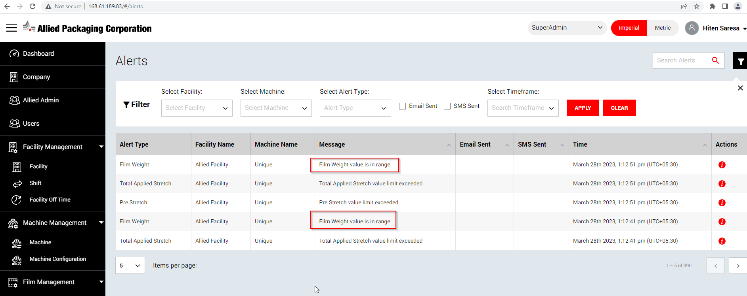

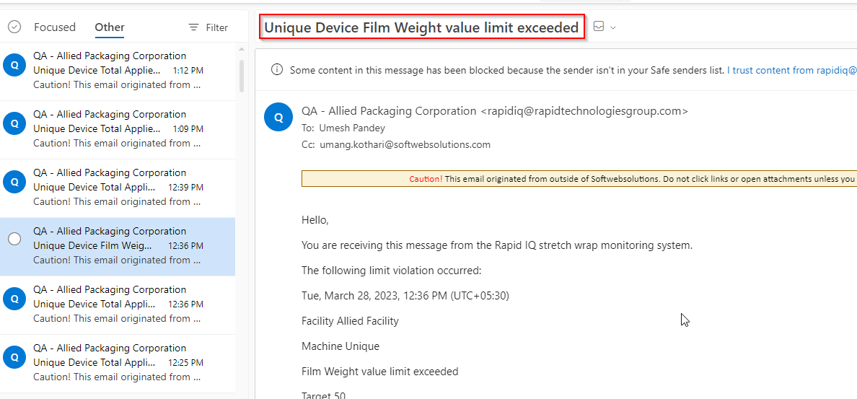

User receives the Alerts record email but when he/she filter the Alert record by checking ‘Email Sent’ check box from Allied portal , do not found any record in grid.

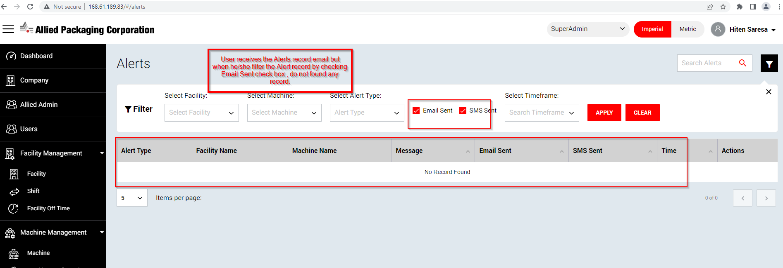

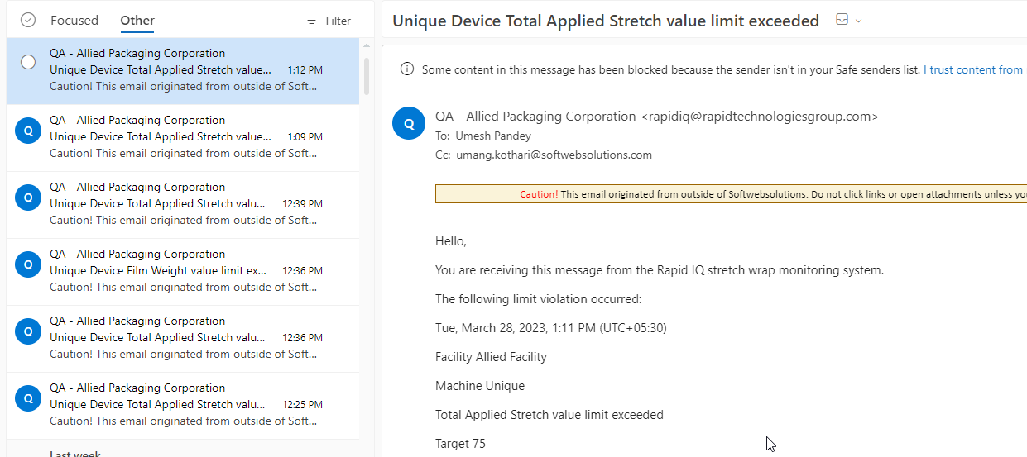

**Date: 13th April 2023**

- While add and submit a New User, throwing “Mail do not send to user. Please try again” error but after refreshing the page, user seeing as added on grid.

- After refreshing the page , “Back” button is not clickable from Machine RealTime Data page

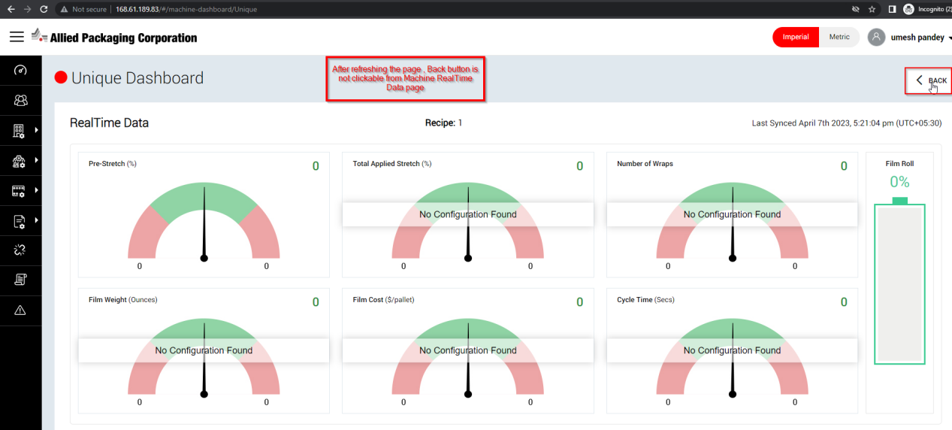

- Spell issue find in “rights” wording when user [(umesh.pandey@softwebsolutions.com)](mailto:(umesh.pandey@softwebsolutions.com)) do not have rights of “Web Break” and select it.

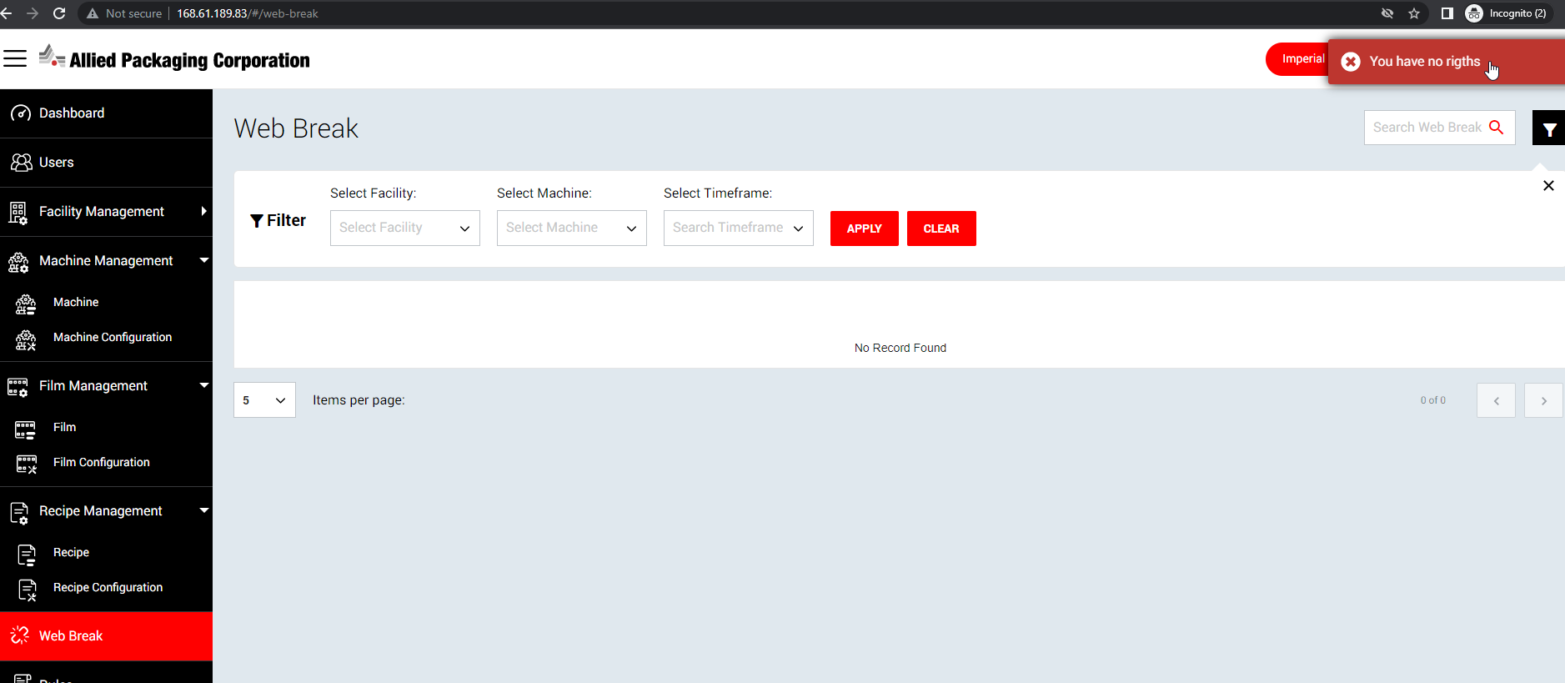

**- Suggestion**: In across application, “Email Address” field should made as a non-editable field.

